All standard hosting subscriptions come with 1 free email address

Premium (HG) and Ecommerce (SC) subscriptions come with 2 free email addresses

We sell additional emails in bundles of 5. Users can purchase 5 or 10 or upgrade from 5 to 10

* 5 emails = $19 @ 50% discount - renewal $38/yr
* 10 emails = $38 @ 50% discount - renewal $76/yr

All users will see a 5 mailbox splash page during their order flow which is priced at $19 for 5 mailboxes.

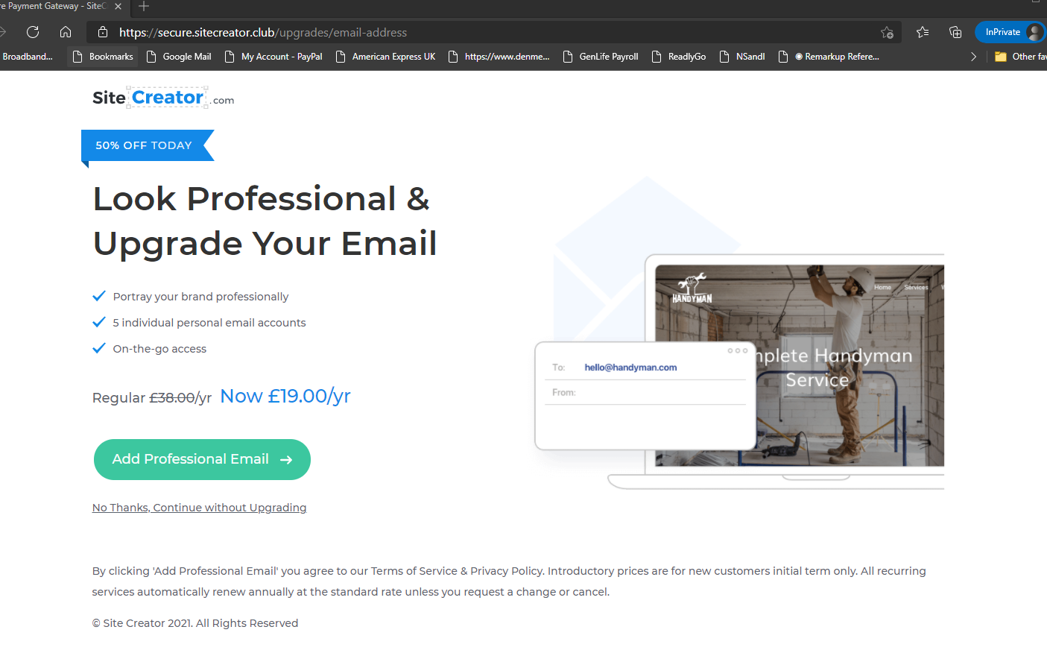

Users can create their free email address, buy email bundles and access their webmail on https://my.sitecreator.club/emails

If a user upgrades from 5 mailboxes to 10, they will be charged the prorated value of the 10 emails based on how long they have been using their 5 emails.

* If they upgrade to 10 mailboxes from 5 on the same day they will pay $19 each time